**“EMOJIFY: CREATE YOUR OWN EMOJI WITH DEEP LEARNING”**

Vaishnavi Thote*1, Samiya Pervez#2, Chetna Satla#3

Project Guide: Prof. Ashwini Bagde

Electronic and Telecommunication,

Dr. D Y Patil School of Engineering, Pune, Maharashtra, India

***Abstract*—In this paper, we use the FER2013 dataset to feed a convolutional neural network (CNN) architecture that can differentiate emotion from pictures. The CNN model is built using Kera’s layers, and the facial expressions are classified using a deep learning model. After that, the emotion will be assigned to an emoji or an avatar. We put our models to the test by creating a real-time vision machine that employs our proposed CNN architecture to do face recognition, emotion classification, and emoji mapping all in one combined phase. In this review paper, we give a complete study of the current body of work on emoji, looking at how they've evolved, how they're used differently, what purposes they have, and what research has been done on them.**

***Keywords—Convolution Neural Network (CNN), face detection, emotion classification, emoji mapping, CNN architecture***

# **INTRODUCTION**

Emoji are becoming increasingly widely employed in network communication. The ways in which they are used are diversifying as well. They are tightly linked to marketing, legislation, health care, edibles, and a variety of other fields. Emoticons have become a necessary component of modern digital communication. Nonverbal conduct communicates comprehensive feelings and impassioned facts in order to convey concepts, oversee connections, and clarify importance in order to improve the effectiveness of discussions [1][2]. Sending emoticons, which are practical symbols (e.g.,) overseen by the Unicode Consortium and distinguishable using Unicode characters and presented by a systems font bundle, is one technique of illustrating nonverbal activities.

Emoticons allow people to express themselves freely, and they can be managed as textual content structures while being considered as display screen designs. Aside from Pohl's Emoji Zoom[3], which advocates for a zooming-based interface, emoticon on cell phone consoles now requires users to choose from vast lists (one for each class of emoticon) (e.g., Apple iOS 10 emoticon console 2 in Fig. 1). This turns emoticon passing into a "linear search task"[3], which we expect to result in user unhappiness given the growing diversity of emoticons. While no previous work specifically tackles this, efforts such as Emojipedia 3 describe the need for more emoticon search.

To address this, we recommend a framework and approach that uses consumers' face emotional expressions as framework input to filter out emoticons using emotional classification. Despite the fact that emoticons can represent activities, objects, nature, and unique symbols, the most commonly used emoticons are faces with specific emotions[4][5][7].Furthermore, previous research has shown that emotions can be placed through assumption (Emoji Sentiment Ranking with Novak[6]), literary notifications containing emoticons show differences in 3-valued conclusion throughout stages[8], and emoticons for faces can be placed through valence and arousal[7].Emoji prediction is a fun variant of sentiment analysis. The goal of this project is to build a deep learning model that can categorize face emotions from photographs. The labeled emotion can then be mapped to an emoji or an avatar. A depressed individual, for example, may send a sad face emoji so that others could understand his or her situation.

The goal of this project is to build a deep learning model that can categorize face emotions from photographs. The labeled emotion can then be mapped to an emoji or an avatar.

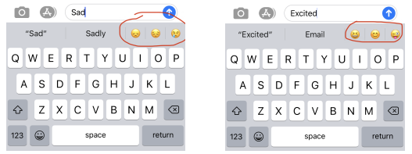

Fig 1:Examples of emoji prediction in android keyboards

# LITERATURE SURVEY

A literature review contains all investigations on a particular topic that have been undertaken by various researchers. We began our work by carefully studying the project and research papers in order to expand our knowledge on the subject.

Whether on the web or on phones, virtual platforms are available (Vissersand Stolle, 2014). Online applications and stages are now used to communicate and trade ideas. Regardless, communicating emotions is difficult. Emoticon characters are becoming increasingly popular, and so the range of these characters has grown. Regardless, the currently available emoticon characters are limited to specified characters. These characters must also be complex and varied. This investigation looked at techniques for clients to "emojify" their images in order to modify emoticon characters. This research not only enables people to create new and unique ways of conveying emotions, but it also provides rationale for more emoticon character changes.

It is sparked by two findings from the literature: emoticons' ability to transmit emotions is one of their most important capabilities, and the majority of emoticons used are face emoticons. Cramer discovered that emoticons were used to communicate emotions in 60% of the texts analyzed by US members. Faces constituted six of the top ten emoticons in an Instagram emoticon research, demonstrating that people use emoticons to describe their feelings as frequently as possible. Furthermore, according to a SwiftKey report from 2015, faces accounted for about 60% of emoticon use in their analysis of billions of messages. Finally, they discovered that emoji stickers were primarily used for transmitting emotions in a subjective report from Lee on emoji sticker usage.

When using written language, small and simple drawings, often known as emoticon characters, are used to enhance moods (Yeole, Chavan, and Nikose, 2015). They have exceptional semantic and impassioned characteristics, but are firmly associated with marketing, law, medical care, and a variety of other fields. The study of emoticons has become a fascinating topic in academia, and more and more scholars from domains such as computing, communication, marketing, behavioral science, and others are looking at it. Emoticon characters are becoming increasingly popular, as a result.

After much thought about the main ideas, pros and cons of our project, and the possibility of successful completion of the project, we began our work by carefully studying the project and research papers in order to expand our knowledge on the subject. Our basic ideas and projects are similar.

# **PROPOSED METHODOLOGY**

***3.1 Details of Hardware & Software:***

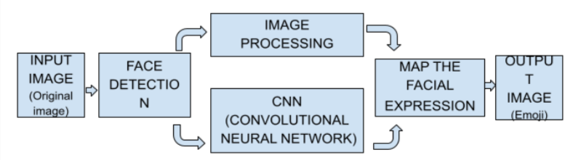

Fig 2: Block Diagram

* Hardware Requirements:

Laptop (64-bit architecture,4-8 GB RAM), Camera(8 MP)

* Software Requirements:

Operating System: Windows 10

Framework and tools: Opencv, Tensor flow

Language: Python

Technology used: Image pre-processing, Tensor Flow, Keras, OpenCv, Deep Learning.

***3.2 Steps for Proposed System:***

In preparation for educational data, we'll capture video via webcam with a python script that includes OpenCV and Imutils, as well as apply the HAAR cascade classifier and construct an image dataset by capturing the frames of a specific emotion as a face expression. Another option is to get images from Kaggle that have previously been used to characterize an emotion dataset, such as the FER2013 dataset.

## Input the dataset

Images from the FER 2013 dataset that were used to classify emotions are shown below. These images are divided into categories based on the emotion expressed in the facial expressions: happiness, neutral, sadness, anger, surprise, disgust, fear.

## Data pre-processing and applying augmentation Strategies.

Image data augmentation is used to increase the size of the training dataset in order to improve the model's performance and generalization capacity. The ImageDataGenerator python module is used to rescale images from [0,255] to [0,1].

The following are some of the advantages:

* All photos are created the same way - some have a large pixel range, while others have a small pixel range. The high range picture tends to cause more loss, whilst the low range image causes less loss. However, the aggregate of the two will contribute to the back propagation update.
* Using a typical learning rate, we can directly reference the learning rate from another's work if both works execute the scaling preprocessing over the same data set of images. Otherwise, a higher pixel range image will result in more loss and will require a lower learning rate.

## Neural Network architecture.

The next stage is to create a convolutional neural network after preprocessing the data. The input layers, hidden layers, and output layers make up the convolution layer. We add convolutional layers with filters depending on the design of the neural network.

## Accuracy and loss.

On training data, we achieved a precision of 77 percent with a loss of 0.36, while on validation data, we achieved a precision of 62 percent with a loss of 0.36.

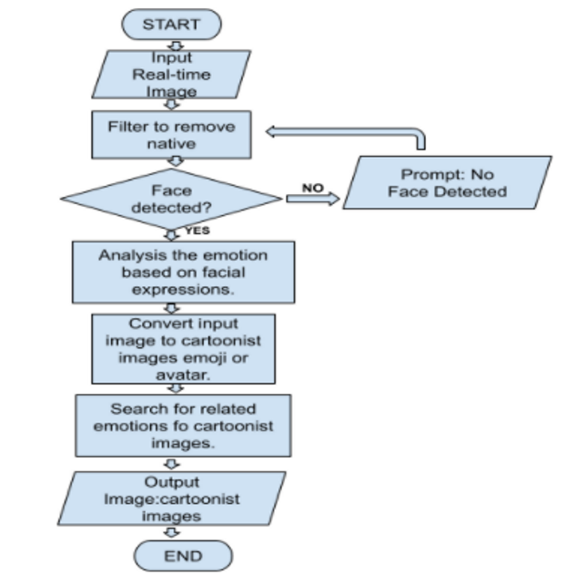

Fig 3: Flowchart

***3.3 Output of the Implemented Model.***

The implemented model's real-time result is shown below.

Based on facial expression, the model classifies the emotion and assigns it to an emoji or avatar.

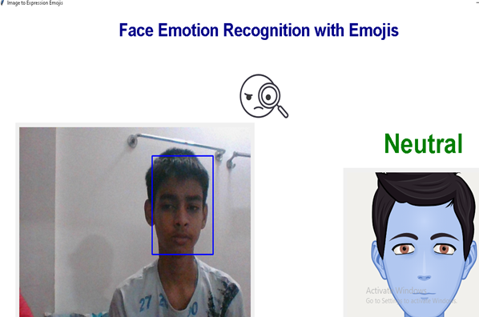

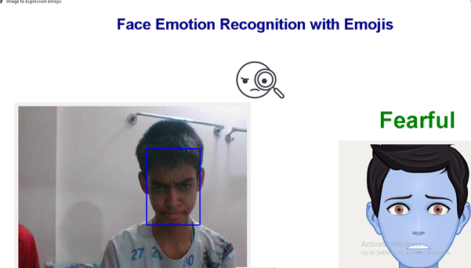

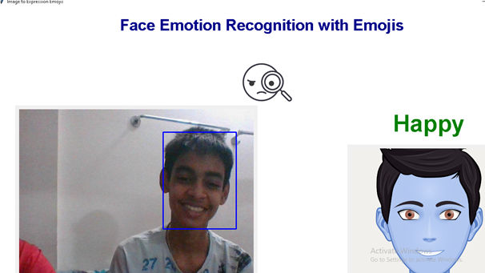

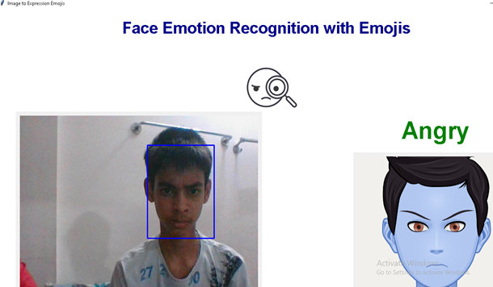

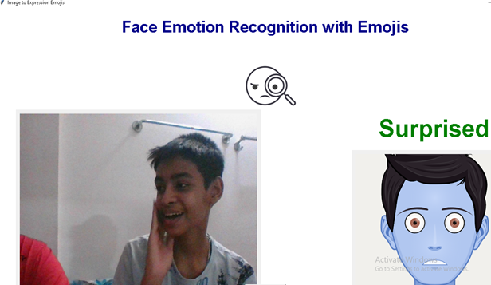

Fig 4: Result

# **CONCLUSIONS**

Emojis are symbols used to represent nonverbal cues. With advancements in computer vision and deep learning, it's now possible to detect human emotions in images. We were able to classify human face expressions in order to filter out and map relevant emojis in this research.

# **V. ACKNOWLEDGEMENT**

It gives us great pleasure to present this report on Emojify : Create your own emoji with Deep Learning towards partial fulfillment of the requirement of Savitribai Phule Pune University, for the award of the degree of Bachelor of Engineering (Electronics & Telecommunication Engineering). We take this opportunity to convey our deepest gratitude to our guide Prof. Ashwini Bagde, who guided us at every juncture of need. Our special thanks to the Head of Electronics & Telecommunication Engineering Department and Principal of D. Y. Patil School of Engineering, Lohegaon for their cooperation and support. We are also thankful to all faculties of the Electronics & Telecommunication Engineering Department for their help.

# **VI. REFERENCES**

1. Shreyasee Das and others, Emojis: The Language of the future?ISSN Research India Publication(2017)
2. Ankur Ankit, Dhananjay Narayan & Others,Transformation of Facial Expression into  corresponding Emoticons, Blue Eyes Intelligence Engineering Sciences Publication(2019).
3. S. Chairunnisa and B.A.S. Analysis of Emoji and Emoticon Usage in Interpersonal   Communication of Blackberry Messenger and WhatsApp Application User International Journal of Social Science and Management(2017)
4. Linda K. Kaye How emotional are Emoji?: Exploring the effect of emotional valence on the processing of Emoji by ELSEVIER(2021)
5. Mohd Zuwiri bin Mat Saad and others Analysis of The Use of Interpersonal  Communication Emoji on Whatsapp Use Among Students Published by Atlantis Press (2018)
6. Qiyu Bai and others A Systematic Review of Emoji: Current  Research and Future  Perspectives Published byFront Psychol(2019)
7. Julia Sick and others The Meaning of Emoji to Describe Food Experiences in  Pre-Adolescents Licensee by MDPI(2020)
8. Elsi Kaiser & Patrick G. GroszAnaphoricity in Emoji: An experimental   investigation of face and non-face Emoji by the LSA (2021)
9. Hannah Miller, Jacob Thebault-Spieker, Shuo Chang, Isaac Johnson, Loren Terveen, and Brent Hecht. 2016. "blissfully happy" or "ready to fight": Varying interpretations of emoji. In Proc. ICWSM 2016. AAAI press, 259–26
10. Petra Kralj Novak, Jasmina Smailovi´c, Borut Sluban,and Igor Mozetiˇc. 2015. Sentiment of Emojis. PLOSONE 10, 12 (12 2015), 1–22.
11. Garreth W. Tigwell and David R. Flatla. 2016. Oh That’s What You Meant!: Reducing Emoji Misunder-standing. In Proc. MobileHCI 16. ACM, New York, NY, USA, 859–866.
12. Channary Tauch and Eiman Kanjo. 2016. The Role Of Emojis in Mobile  Phone Notifications. In Proceed-ings of the 2016 ACM International Joint Conferenceon Pervasive and Ubiquitous Computing: Adjunct (Ubi-Comp’16).ACM, New York, NY, USA, 1560–1565.
13. Jackson Feijó Filho, Thiago Valle, and Wilson Prata. 2014. Non-verbal Communications in Mobile Text Chat: Emotion-enhanced Mobile Chat. In Proc.MobileHCI ’14. ACM, New York, NY, USA, 443–446.
14. B. Anand, B. B. Navathe, S. Velusamy, H. Kannan, A. Sharma, and V. Gopalakrishnan. 2012. Beyond touch: Natural interactions using facial expressions. In proc. CCNC ’ 12. 255–259.
15. M. Young, The Technical Writer’s Handbook. Mill Valley, CA: University Science, 1989.